**UNIT 5: AROUND TOWN**

**Lesson 1 (p. 38)**

* **PHẦN HỌC SINH CHÉP VÀO TẬP**

**NEW WORDS: ( PAGE 38)**

1. *jeans (n)* /dʒiːnz/: quần jean
2. *sweater (n)* /ˈswetər/: áo len tay dài
3. *customer (n)* /ˈkʌstəmər/: khách hàng
4. *sales assistant (n)* /seɪl əˈsɪstənt/: nhân viên bán hàng
5. *changing room (n)* /tʃeɪndʒɪng rʊm/: phòng thay đồ
6. *T-shirt (n)* /ˈtiː ʃɜːrt/: áo thun
7. *Size (medium, large, extra large)* /saɪz/ : kích cỡ ( trung bình, lớn, rất lớn)

CHECKING VOCABULARY:

1. We often wear shorts and…………. for games. Because it's easier for us to move around in this outfit.
2. Put a …………. on if you're cold.
3. Mr. John is my regular …………. He often buys clothes at my store.
4. I never wear …………. to work.
5. People can try on clothes at a ………….…. before buying them.
6. Sales assistant: Hi, can I help you?

Customer: I want to buy this model.

Sales assistant: Ok. What is your ………….?

Customer: Do you have this dress in a medium?

Sales assistant: Yes.

1. Mary is a friendly …………...She always smiles when customers ask.

**PRONUNCIATION ( PAGE 40)**

/d/ + /j/ = /dʒ/

/d/ là phụ âm đầu của did, /j/ là phụ âm đầu của you = /dʒə/

/dʒ/ đọc như âm đầu trong từ just, juice, jump

B. /dʒə/ have these pants in blue?

/dʒə/ have this jacket in green?

C. /dʒə/ have these socks in red?

/du ju/ have this shirt in pink?

**NEW WORDS ( PAGE 40)**

* A small size (n): cỡ nhỏ (S)
* A medium size (n): cỡ vừa (M)
* A large size (n): cỡ lớn (L)
* An extra large size (n): cỡ rất lớn (XL)
* Try on (v): thử quần áo
* the changing room (n): phòng thử đồ
* How much is it/ are they? : Nó/ chúng có giá báo nhiêu
* It’s/ They’re ______ dollars/ dong: Nó/ chúng có giá _______ đô/ đồng.
* **PHẦN HỌC SINH TỰ HỌC**

**LISTENING: ( PAGE 38) ( HỌC SINH TỰ HỌC)**

Listen and fill in the blanks.

Mom: Cassie, look. I like this (1)…………..

Cassie: Oh, that’s nice, mom. What’s about this pink T- shirt? Do you like it?

Mom: It looks (2) ………….

Sales assistant: Hi. Can I help you?

Cassie: Yes, please. Do you have this pink (3) ………… in a small?

Sales assistant: Let me check. I’m sorry. We only have a (4) …………. in black.

Cassie: Oh…

Sales assistant: Here it is. Do you want to (5) …………. this on?

Cassie: Hmmm, OK. Where is the (6) ………….?

Sales assistant: It’s just over there.

Cassie: Thanks

Mom: How much is this sweater.

Sales assistant: It’s (7) …………...

Mom: That’s fine. I’ll take it.

Cassie: Mom, look!

Mom: You look great. How much is the T-shirt?

Sales assistant: It’s (8) …………...

Mom: I’ll take that, too.

**PRACTICE ( PAGE 40) ( HỌC SINH TỰ HỌC)**

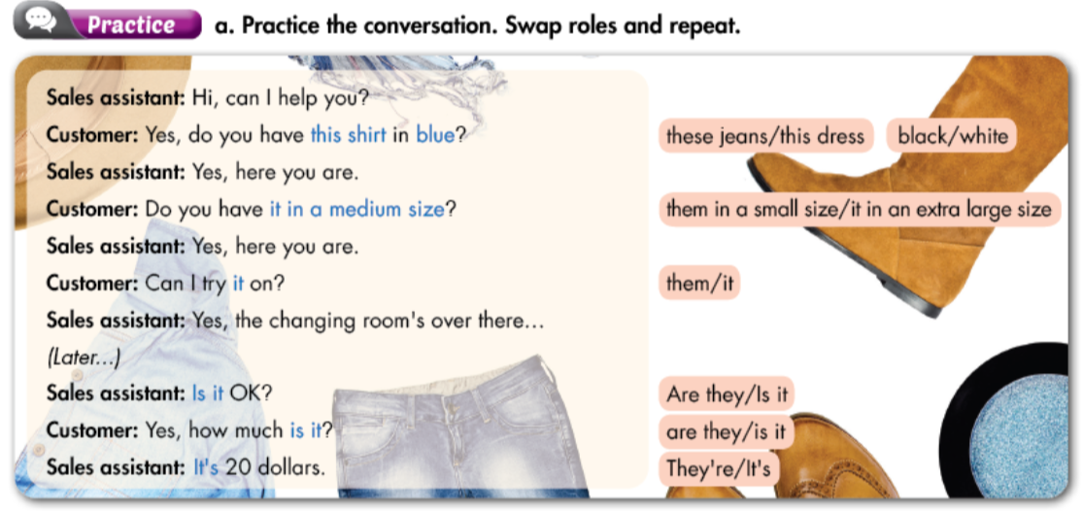

**SPEAKING ( PAGE 40) ( HỌC SINH TỰ HỌC)**

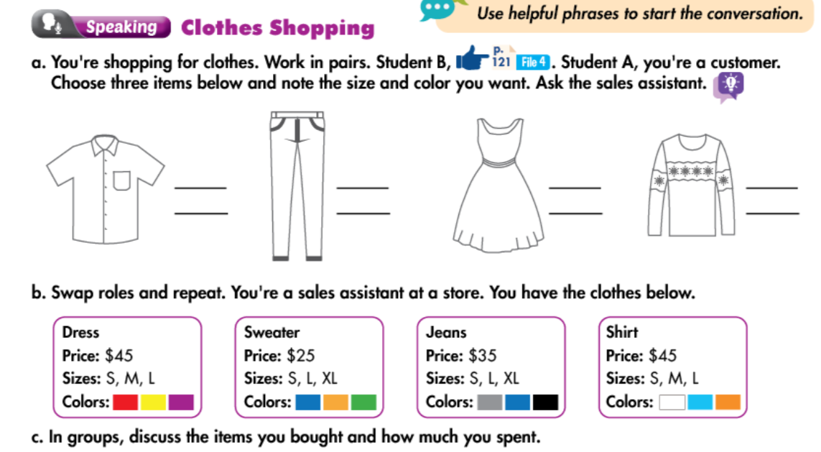

**Sales assistant: Hi, can _______________________?**

**Customer: Yes, do you have _______ in ________?**

**Sales assistant: Yes, here ___________. / Sorry, we don’t have it.**

**Customer: Can I try it on? / Do you have ______________?**

**Sales assistant: Yes, the changing room’s __________________**

**Sales assistant: Is it __________?**

**Customer: Yes, how much ____________? / I want to try another one.**

**Sales assistant: It’s ____________/ They’re _________________.**